INTERNSHIP

PROJECT REPORT

**HOME INVIOLABILITY**



**Hexnbit Online Internship**

**www.hexnbit.com**

*Intern Detail*

HOME INVIOLABILITY

**Name of Project:** ………………………………………………………………………………………………………………….

Coka Somesh Rao

**Name of Intern:**  ………………………………………………………………………………………………………………….

+919030772705

**Intern’s Ph. no.:**  ………………………………………………………………………………………………………………….

3-6-319 1401 Namitha Everest bahadurguda, LB nagar

**Intern’s Add.:**  ………………………………………………………………………………………………………………….

JNTUHCEH

**Name of College:** ………………………………………………………………………………………………………………….

Kukatapally, Hyderabad – 500085 Telengana, India

**College’s Add.: ……..**………………………………………………………………………………………………………….

ECE

**Branch:**  ………………………………………………………………………………………………………………….

14/10/2020

**Project Submission Date:** ………………………..

*Table of content*

|  |  |  |
| --- | --- | --- |
| S.No. | Headings | Page No. |
| 1 | *Project Application and List of Hardware & Software used* | 01 |
| 2 | *Flow chart* | 02 |
| 3 | *Project Description* | 03 |
| 4 | Code and *List of Reference* | 04-08 |
|  |  |  |
|  |  |  |

*Project Application*

HOME INVIOLABILITY is a very peculiar project IOT field and we are creating an inexpensive security system for homes as well as industrial use.   
The system will inform the owner about any unauthorized entry through door by sending a SMS to the user’s mobile device.

*List of Hardware & Software used*

**List of Software:**

* Arduino IDE
* ADAfruit
* IFTTT

**List of Hardware:**

* Node MCU
* PIR sensor
* Battery and Bred broad

*Flow chart*

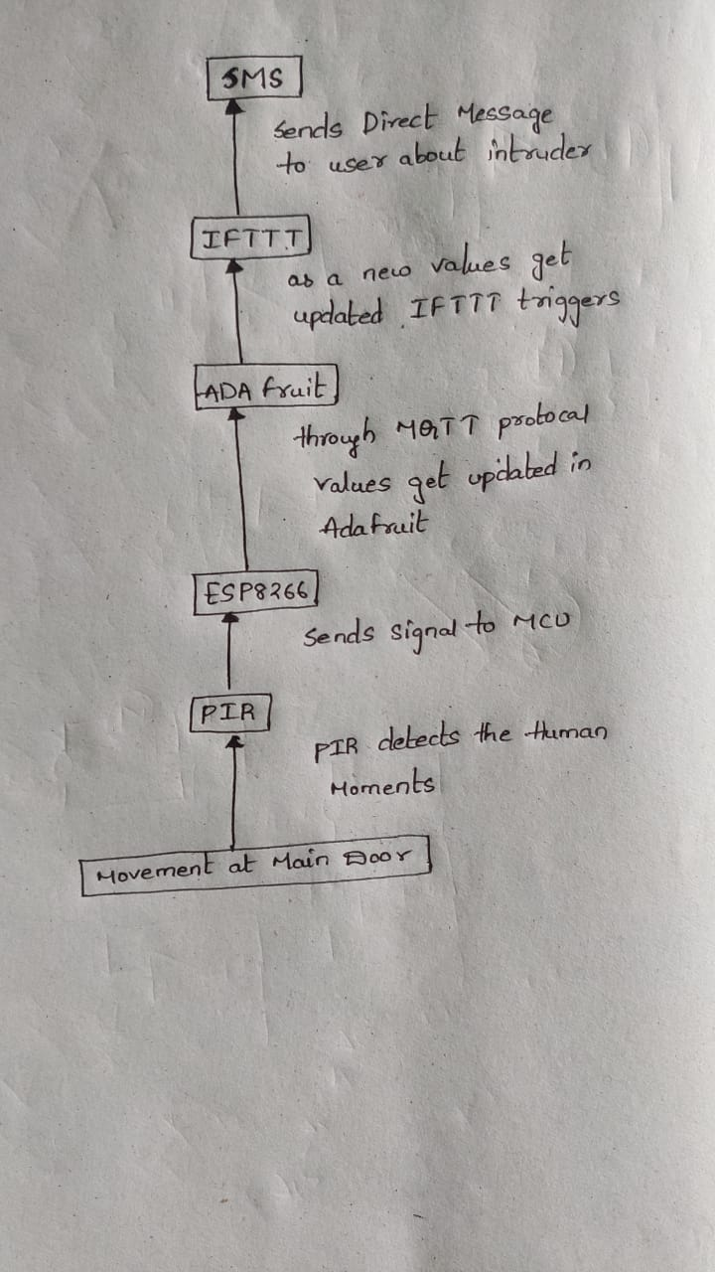

*Project Description*

When some Intruder tries to get into your house in your absence, PIR sensor detect the motion of the intruders through his/her body heat & Immediately it sends alarming signal to MCU that some motion has been detected.   
Now, through the MQTT protocol the node MCU publishes the message in ADAFRUIT server. This happens every time a new message gets published when a motion is detected at the door every time when adafruit server gets a new message, the IFTTT services gets Triggered and the message is send to a user's mobile device saying there is a Intruder at restricted place and u can take necessary action .  
its very useful system come handy when you have something important at your place and u need to have good security .

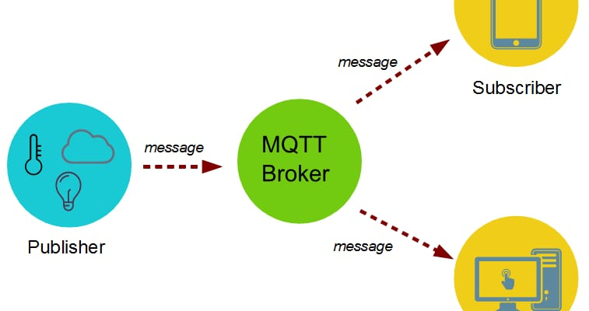

*Code*

**#include "ESP8266WiFi.h"**

**#include <SoftwareSerial.h>**

**//*********************** PIR Motion Sensor Setup \*\*\*\*\*\*\*\*\*\*\*\*\*\*\*\*\*\*\*\*\*\*\*\*\*\*\*\*\***

**int inputPin = D6;**

**int val = 0;**

**//************************* WiFi Access Point \*\*\*\*\*\*\*\*\*\*\*\*\*\*\*\*\*\*\*\*\*\*\*\*\*\*\*\*\*\*\*\*\***

**#define WLAN_SSID "Honor 9 Lite"**

**#define WLAN_PASS "qwerty1234”**

**//************************* Adafruit.io Setup \*\*\*\*\*\*\*\*\*\*\*\*\*\*\*\*\*\*\*\*\*\*\*\*\*\*\*\*\*\*\*\*\***

**#define AIO_SERVER "io.adafruit.com"**

**#define AIO_SERVERPORT 1883**

**#define AIO_USERNAME "Tangent_12211"**

**#define AIO_KEY "aio_Bujy549zTifhvF8eON1YxEDGqcaJ"**

**//************ Global State (you don't need to change this!) \*\*\*\*\*\*\*\*\*\*\*\*\*\*\*\*\*\***

**WiFiClient client;**

**Adafruit_MQTT_Client mqtt(&client, AIO_SERVER, AIO_SERVERPORT, AIO_USERNAME, AIO_KEY);**

**//****************************** Feeds \*\*\*\*\*\*\*\*\*\*\*\*\*\*\*\*\*\*\*\*\*\*\*\*\*\*\*\*\*\*\*\*\*\*\*\*\*\***

**Adafruit_MQTT_Publish motion = Adafruit_MQTT_Publish(&mqtt, AIO_USERNAME "/feeds/motion");**

**//************************** Setup \*\*\*\*\*\*\*\*\*\*\*\*\*\*\*\*\*\*\*\*\*\*\*\*\*\*\*\*\*\*\*\*\*\*\*\*\*\*\*\*\*\***

**void setup()**

**{**

**Serial.begin(9600);**

**pinMode(LED_BUILTIN, OUTPUT);**

**pinMode(inputPin, INPUT);**

**Serial.begin(9600);**

**Serial.println();**

**Serial.print("connecting to ");**

**Serial.println(WLAN_SSID);**

**WiFi.mode(WIFI_STA);**

**WiFi.begin(WLAN_SSID, WLAN_PASS);**

**while (WiFi.status() != WL_CONNECTED) {**

**delay(500);**

**Serial.print(".");**

**}**

**Serial.println("");**

**Serial.println("WiFi connected");**

**Serial.println("IP address: ");**

**Serial.println(WiFi.localIP());**

**}**

**//************************ Main Loop \*\*\*\*\*\*\*\*\*\*\*\*\*\*\*\*\*\*\*\*\*\*\*\*\*\*\*\*\*\*\*\*\*\*\*\*\*\*\*\***

**void loop()**

**{**

**connectWifi();**

**MQTT_connect();**

**val = digitalRead(inputPin);**

**if (val == HIGH)**

**{**

**digitalWrite(LED_BUILTIN, HIGH);**

**Serial.println("Motion detected!");**

**if (! motion.publish(val))**

**{**

**Serial.println(F("Failed"));**

**} else**

**{**

**Serial.println(F("Data Sent!"));**

**}**

**} else**

**{**

**digitalWrite(LED_BUILTIN, LOW);**

**Serial.println("Motion ended!");**

**motion.publish(val);**

**}**

**if(! mqtt.ping()) {mqtt.disconnect();**

**}**

**}**

**//********************** WiFi Connect \*\*\*\*\*\*\*\*\*\*\*\*\*\*\*\*\*\*\*\*\*\*\*\*\*\*\*\*\*\*\*\*\*\*\*\*\***

**void connectWifi()**

**{**

**if (WiFi.status() == WL_CONNECTED){ return; }**

**WiFi.begin(WLAN_SSID, WLAN_PASS);**

**while (WiFi.status() != WL_CONNECTED)**

**delay(500);**

**Serial.print(".");**

**}**

**Serial.println("Connected");**

**MQTT_connect();**

**}**

**// ******************* MQTT Connect - Adafruit IO \*\*\*\*\*\*\*\*\*\*\*\*\*\*\*\*\*\*\*\*\*\*\*\*\*\***

**void MQTT_connect()**

**{**

**int8_t ret;**

**if (mqtt.connected()) { return; }**

**Serial.println("Connecting to MQTT... ");**

**uint8_t retries = 3;**

**while ((ret = mqtt.connect()) != 0)**

**{**

**Serial.println(mqtt.connectErrorString(ret));**

**Serial.println("Retrying MQTT...");**

**mqtt.disconnect();**

**delay(10000);**

**if (retries == 0)**

**while (1);**

**}**

**}**

**Serial.println("MQTT Connected!");**

**}**

*List of References*

* www.Instructables.com
* www.Elctronicsforu.com
* www.Youtube.com